Non-indemnified Clinical Study Approval Process

Non-Indemnification Policy
The University of Kentucky (UK) Healthcare Risk Management Committee (UKHC RMC) administers a self- insurance program to protect its physicians from medical malpractice claims, which could result from their participation in the conduct of clinical studies. UKHC RMC review is required for all clinical studies where the sponsor does not provide indemnification or limits time or dollar amount of indemnification for medical malpractice liability, with the exception of studies that meet the exclusion criteria detailed below. UKHC RMC review assesses the medical malpractice liability for conducting a clinical study. UKHC RMC review also determines whether the protection of this program will be given to a clinical researcher for medical malpractice claims that may arise from participation in a particular clinical study. Medical malpractice liability protection is contingent on UKHC RMC review and approval of proposed clinical studies.

It is the responsibility of the principal investigator to initiate the non-indemnification review process for all eligible clinical trials, as defined below, by directing the proposed clinical study protocol for one of the following three reviews: (1) the Markey Cancer Center Protocol Review and Monitoring Committee (PRMC) for cancer clinical trials; (2) the CCTS for investigator-initiated studies utilizing the services of the Center for Clinical and Translational Science, Cardiovascular studies or studies funded by a federal governmental agency (i.e. NIH, NSF, VA, etc.); and (3) the Non-indemnified, Non-cancer Protocol Review Committee for all other non-indemnified studies. Electronic submissions via email are preferred and may help expedite this process.

NOTE: Contact Cliff Iler (Email: clifton.iler@uky.edu or Phone: 323-1161) for any questions regarding protocol eligibility or the non-indemnification submission/review process.

I. Features of Clinical Studies requiring UKHC RMC Review

Inclusion criteria for UKHC RMC Review:
- All non-indemnified human clinical research that is not IRB exempt or expedited regardless of the funding source.
- Surveys and medical record chart reviews are included unless they do not require IRB review.
- All investigator initiated human clinical research for which a drug, device, investigative procedure or financial support are provided by the sponsor, but full indemnification is not provided (i.e. limitation on time or dollar amount).
- All VA cooperative studies utilizing UK services (i.e. VA Merit Awards).
- Studies in which there is no physical risk to the subject but there could be risk to the institution based on social, political or ethical issues.

Expedited Review:
Some studies may qualify for expedited review. Those studies currently include:

1. CCTS funded or co-funded pilot studies
2. Low risk studies as assessed by the Chairperson of one of the review committees.

This review consists of an expedited review and approval by legal counsel with subsequent reporting to the full committee.

Exclusion criteria:

The following studies do not require review by UKHC RMC.

- All IRB exempt protocols
- All IRB expedited protocols.
- Industry supported clinical studies that provide full indemnification.

II. Instructions for submission to the appropriate review committee:

The Principal Investigator (PI) is responsible for reviewing the inclusion/exclusion criteria for the review process. The PI can ask for legal advice on the requirements at 323-1161.

If a study qualifies for review then the PI should initiate the process described below:

A risk assessment needs to be completed by ONE of the following THREE reviews:

- Non-indemnified Non-cancer Review
Chairperson: Matthew Bush, MD
Co-Chair: Agatha Critchfield, MD

This review is for clinical studies that do not have to go through the Markey Cancer Center Protocol Review or the CCTS Protocol Review. For questions regarding submitting for this review contact Matthew Bush, MD (Chairperson) Email: matthew.bush@uky.edu Phone: 859-257-5097

The Clinical Project Risk Assessment Evaluation Form is located on the CCTS web site: http://ccts.uky.edu/ccts/non-indemnification-clinical-study-rmc-approval-process.

To submit an application for review:
- Complete sections I, II, III of the Clinical Project Risk Assessment Evaluation Form.
- Submit the completed Clinical Project Risk Assessment Evaluation Form, Research Description, IRB approval and IRB approved informed consent to Dr. Matthew Bush via email to matthew.bush@uky.edu.
- Once Dr. Bush has completed the risk assessment it will be forwarded to UK Healthcare legal.

After the UKHC RMC review, legal counsel will notify the Principal Investigator and/or their designee (if applicable) of the status of their protocol via email. Upon receipt of this approval, the PI may proceed with the steps necessary to initiate the protocol.

- Non-indemnified Clinical Cancer Research Studies

Markey Cancer Center Protocol Review Committee
Chairperson: Lowell Anthony, MD
Phone (859) 323-8043 Email: Lowell.anthony@uky.edu;
Co-Chair: Val Adams, PharmD
Phone:(859)257-5202 Email: vadam0@email.uky.edu.
This review is for all adult and pediatric cancer-related clinical studies including NCI Cooperative Group Trials. For questions regarding submissions for this review contact the PRMC Coordinator at (859) 257-8213 or by email at UKMCCPRMC@uky.edu.

MCC Investigator-Initiated trials and non-NCI-cooperative studies with incomplete indemnification undergo full PRMC review and Full UK IRB review. NCI Cooperative Group Trials have been vetted at a national level by the NCI and FDA. These undergo expedited PRMC review and NCI Central IRB review (NCI CIRB). For questions regarding submissions for this review contact the PRMC Coordinator at (859) 257-8213 or by email at UKMCCPRMC@uky.edu.

Submission and Review Process for MCC Investigator Initiated Clinical Trials and Non-Indemnified Studies:

- Upon PRMC approval, PRMC Coordinator creates the Risk Assessment Evaluation form for the Chair’s review and signature. At that time, the Regulatory Coordinator/Pediatric Oncology Regulatory Coordinator will obtain IND/IDE number, if applicable. Following IRB approval, the following will be submitted to the RMC:
  - PRMC approval memo(s)
  - Signed Risk Assessment Form (To be signed by PRMC chair or Physician reviewer)
  - Protocol
  - IRB stamped Informed Consent
  - IRB approval letter
- UK Healthcare legal provides expedited or full review based on the level of risk, as assigned by the PRMC Chair or Co-Chair and if approved, sends this notification or requested revisions to mccreg@uky.edu and the principal investigator.

Submission and Review Process for Dual Sponsorship (i.e. Industry/NCI Sponsored, Industry/Consortium, etc) Non-Indemnified Studies:

- Upon PRMC approval, PRMC Coordinator creates the Risk Assessment Evaluation form for the Chair’s review and signature. Following IRB approval, the following will be submitted to the RMC:
  - PRMC approval memo(s)
  - Signed Risk Assessment Form (To be signed by PRMC chair or Physician reviewer)
  - Protocol
  - IRB stamped Informed Consent
  - IRB approval letter
- UK Healthcare legal provides expedited or full review based on the level of risk, as assigned by the PRMC Chair or Co-Chair and if approved, sends this notification or requested revisions to mccreg@uky.edu and the principal investigator.

Submission and Review Process for NCI Sponsored Clinical Trials Utilizing NCI Central IRB:
- Upon PRMC approval, PRMC Coordinator creates the Risk Assessment Evaluation form for the Chair’s review and signature. Following IRB approval, the following will be submitted to the RMC:
  - PRMC approval memo(s)
  - Signed Risk Assessment Form (To be signed by PRMC chair or Physician reviewer)
  - Protocol
  - Informed Consent
  - IRB approval letter
- UK Healthcare legal provides expedited review and if approved, sends this notification or requested revisions to mccreg@uky.edu and the principal investigator.

The Clinical Project Risk Assessment Evaluation Form is located on the CCTS web site: http://ccts.uky.edu/ccts/non-indemnification-clinical-study-rmc-approval-process.

- CCTS Protocol Review
Chairperson: Susan Smyth, MD

This review is for all clinical studies that utilize the CCTS or are Cardiovascular studies or are studies funded by a federal governmental agency (i.e. NIH, NSF, VA, etc.). For questions regarding submissions to this committee contact Susan Smyth, MD (Chair) Email: ssmyt2@email.uky.edu; Phone: (859) 323-2774

The Clinical Project Risk Assessment Evaluation Form is located on the CCTS web site: http://ccts.uky.edu/ccts/non-indemnification-clinical-study-rmc-approval-process.

To submit an application for review:
- Complete sections I, II, III of the Clinical Project Risk Assessment Evaluation Form.
- Submit the completed Clinical Project Risk Assessment Evaluation Form, Research description (Form B) or study protocol, IRB approval, and IRB approved informed consent to: mbart00@email.uky.edu (Marietta Barton-Baxter).
- Once Dr. Smyth has completed the risk assessment it will be forwarded to UK Healthcare legal.

After the UKHC RMC review, legal counsel will notify the Principal Investigator and/or their designee (if applicable) of the status of their protocol via email. Upon receipt of this approval, the PI may proceed with the steps necessary to initiate the protocol.

Even though IRB approval has been obtained, if the Risk Management Committee has not given approval, THE STUDY MUST NOT BE STARTED.
If an investigator does not forward a study for review that qualifies for Inclusion in the Indemnification Process and a problem occurs and a claim is made, the University is not obligated to defend the investigator.

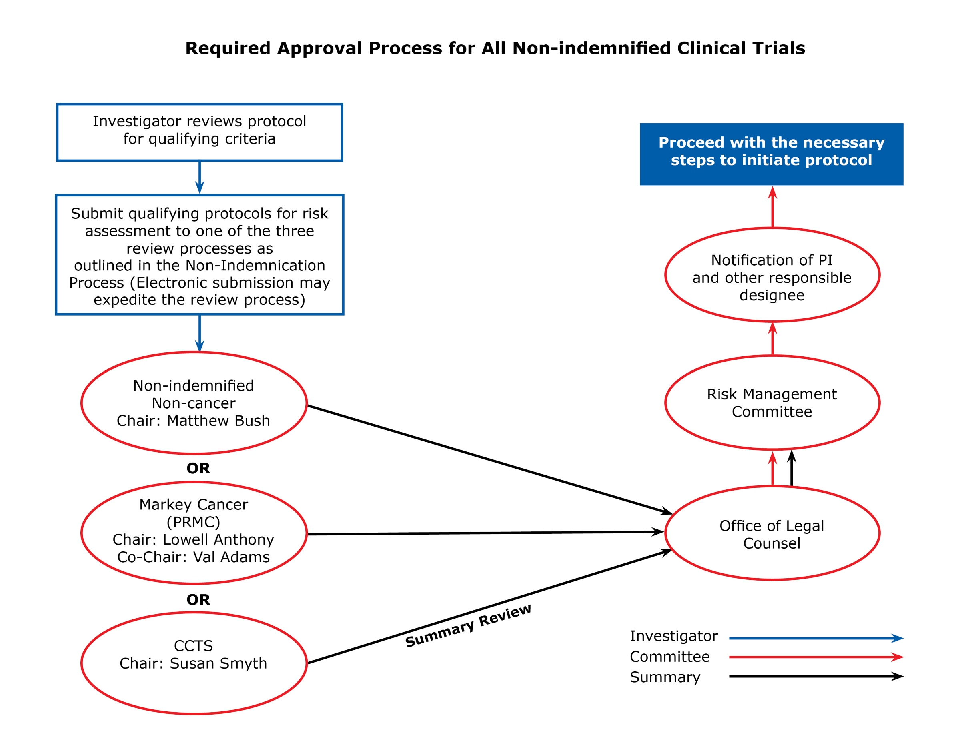

III. Flow Chart Points to Consider:

- Although there are occasions when Sponsored Projects may eventually obtain indemnification, do not delay your protocol by waiting for this to occur. This may happen on rare occasions and on these occasions the work will have been unnecessary — but this is worth the effort to generally move the process forward as quickly as possible.

- Electronic submission to the appropriate scientific review committee is the preferred method and will help expedite this process.

IV. Reconsideration Process
If the protocol does not receive UKHC RMC approval, the PI can make revisions to address the UKHC RMC’s concerns and resubmit to the UKHC RMC for reconsideration. However, the decision of the UKHC RMC is final.

V. Modification to Protocol
During the course of the study if a modification to the protocol results in an increased risk level then legal
counsel should be notified (Cliff Iler Email: Clifton.iler@uky.edu or Phone: 323-1161). Legal counsel will determine whether or not the protocol will need to be reviewed in order to continue coverage. If the study requires review a summary of the changes being made along with the revised documents and IRB approval should be sent to Cliff Iler (Email: Clifton.iler@uky.edu) for review.

VI. Change in Principal Investigator

If there is a change of principal investigator during the study. Notify the contact for the review committee for which you submitted the initial review and copy Cliff Iler (Email:Clifton.iler@uky.edu) and Margaret Pisacano (Email: mmpisa2@uky.edu) so that the records can be updated to reflect this change.

Revised 11/1/12
Revised 3/20/13
Revised 5/28/14
Revised 7/24/14
Revised 7/7/15
Revised 9/14/15
Revised 5/13/16
Revised 11/10/16
Revised 3/16/17
Revised 5/16/17
Revised 7/20/18

